A COMPREHENSIVE REPORT ON

**PASSWORD BASED LOCK SYSTEM**

AS PART OF PROJECT FOR THE COURSE OF

EMBEDDED SYSTEMS (ECL 309)

SUBMITTED BY

YASH SACHIN PAWAR BT16ECE020

ADITYA DHOKE BT16ECE008

YASHIKA BAJAJ BT16ECE009

UNDER GUIDANCE OF PROFESSOR VISHAL SATPUTE

Introduction:

In this project we have successfully created a digital lock which checks the password entered by user.

In this rapidly progressing world it is quite advantageous to digitize even tradition locks as keys are replaced by passwords.

These passwords range from a 4-digit number combination to more advanced types such as fingerprint sensor and retinal scanners.

For this project we have used 4-digit number combination.

It has various advantages over traditional locks. Passwords cannot be stolen as simply as keys. Also we could trust someone with our password in time of emergencies. Also digital locks cannot be picked.

If given some additional features, if someone opens it by force, the lock would smartly raise alarm.

Requirements:

* 8051 microcontroller
* 4x4 matrix keypad
* LEDs for status indication
* Assembler such as keil
* Programmer for 8051
* General electronic components
  + Such as wires, resistors, capacitors, BJT etc

Circuit diagram:

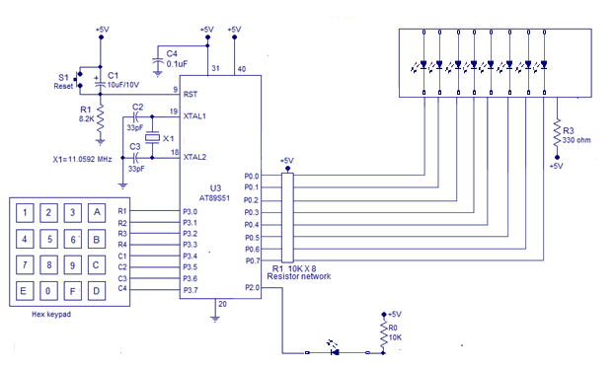

Block diagrams:

uC 8051

PORT

Status indicator LEDs

   

4x4 Matrix

Keypad

Success indicator LED



PORT

PORT

Working:

* User is required to enter password with length of four digits.
* A 4x4 matrix keypad is used for this purpose.
* As each key is pressed, status indicator LEDs glow one by one.
* If entered password is identified as correct password, Success indicator LED glows for a while.
* Lock is opened.

4x4 matrix interfacing:

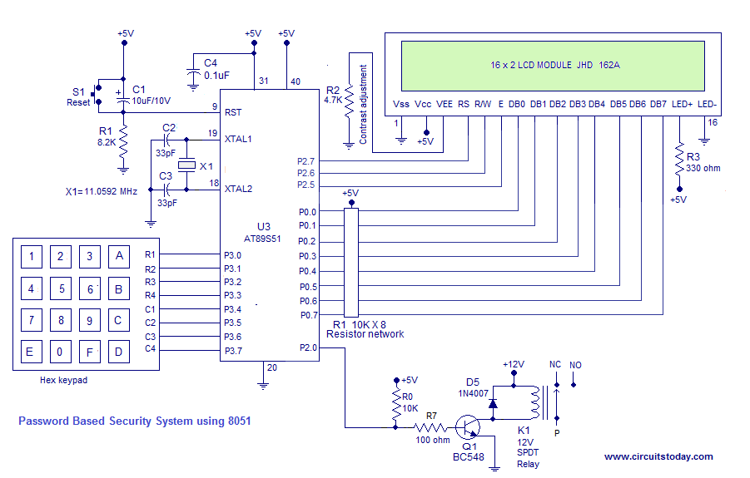

Columns

Rows

To detect a pressed key, the **microcontroller** grounds all rows by providing 0 to the output latch, and then it reads the columns. If the data read from the columns is 1111, no key has been pressed and the process continues until a key press is detected. However, if one of the column bits has a zero, this means that a key press has occurred.

After a key press is detected, the **microcontroller** will go through the process of identifying the key.

Starting with the top row, the **microcontroller** grounds it by providing a low to first row only; then it reads the columns and checks for any zero. If not found program proceeds to nest row. This process continues until the row and column of pressed key are identified.

Knowing both row and column of the pressed key, the key is successfully identified and stored.

Status Indication LEDs and Success indicator LED:

A set of 4 LEDs, connected to a port of uC 8051, inform the user about how many digits have been already entered.

When a key is pressed, the number of glowing LEDs increases by 1.

When all 4 digits are entered all LEDs glow after which user entered combination is matched with correct password and if password is correctly matched, Success indicator LED glows for a while, else it is off.

After this all LEDs are reseted to off state.

Future developments:

The LEDs, which indicates the status, are to be replaced by a LCD display which is more user-friendly.